# 

**A PROJECT REPORT ON**

**FAST FOOD POINT**



**DEVELOPED BY**

**PRATVI JIKADRA**

**GUIDED BY**

**PROF. PRASHIL MAHETA SIR**

**SUBMITTED TO**

**GLORIOUS COLLEGE OF COMPUTER SCIENCE**

**SAURASHTRA UNIVERSITY, RAJKOT–360 005**



**BCA – SEM 6TH YEAR – 2025**

# PREFACE

**Fast food** has become an essential part of modern-day dining due to its convenience, affordability, and quick service. With the increasing demand for fast food, managing orders efficiently, ensuring customer satisfaction, and maintaining business operations have become crucial for restaurants.

This project, **Fast Food Point**, is designed to streamline and automate the process of ordering and managing fast food services. It aims to provide a user-friendly interface where customers can place orders seamlessly, while administrators can manage orders, track inventory, and monitor sales.

Developed using **NetBeans IDE** with **GlassFish Server**, this project utilizes **Java** for the backend and **Microsoft access database** for database management. The database includes a **‘Person’** table that stores customer details, including their name and photo, ensuring a personalized user experience.

Through this project, I have gained valuable experience in **database management, server-side development, and user interface design**. This project not only showcases my technical skills but also highlights my ability to solve real-world business challenges through software development.

I sincerely hope that **Fast Food Point** will serve as an efficient solution for fast food businesses and will contribute to enhancing customer satisfaction and business growth.

**ACKNOWLEDGEMENT**

I take this opportunity to express my heartfelt gratitude and deep regards to my guide, **Prof. Prashil Maheta Sir** (**Glorious College** **of Computer Science**), for his exemplary guidance, continuous support, and encouragement throughout the course of this project. His valuable insights, timely suggestions, and constructive feedback have been instrumental in shaping this project successfully.

I would also like to extend my sincere thanks to **Prof. Prashil Maheta Sir** once again for his constant motivation, valuable information, and expert guidance, which helped me navigate through the various stages of this project with confidence and clarity.

Furthermore, I am deeply grateful to all the **faculty members of the BCA course** (**Glorious College of Computer Science**) for their unwavering support and the knowledge they have imparted to me in their respective fields. Their guidance has played a crucial role in my academic growth and project development.

Lastly, I express my profound gratitude to **the Almighty, my parents, and all those who have directly or indirectly supported me** in completing this project. Their unwavering faith, motivation, and blessings have been my biggest strength throughout this journey.

**Thank you all!**

|  |  |
| --- | --- |
| 1 | Project Introduction |
| 2 | Project Profile |
| 3 | Project Definition |
| 4 | System Analysis |
| 5 | What is Java language ? |
| 6 | What is HTML , CSS, JavaScript ? |
| 7 | What is JSP ? |
| 8 | What is Servlet ? |
| 9 | What is web Server? How Works GlassFish Server? |
| 10 | Project Diagram   * User Side * Admin Side |
| 11 | Data Dictionary |
| 12 | Physical Layout   * User Side Layout Screenshot * Admin Side Layout Screenshot |
| 13 | Contact Us Info |
| 14 | Project Scheduling |
| 15 | Bibliography |

## 

**INDEX**

**INTRODUCTION**

In today's fast-paced world, fast food has become an integral part of urban lifestyles. To streamline the ordering process and enhance customer experience, **Fast Food Point** is designed as a comprehensive food ordering and management system. This project aims to provide a user-friendly platform where customers can browse the menu, place orders, and make payments efficiently.

The system will help fast food businesses manage their operations effectively by automating order processing, inventory tracking, and customer management. It eliminates the need for manual order-taking, reducing errors and improving service speed.

Built using **Java, NetBeans IDE, GlassFish Server, and a database for data storage**, this system ensures seamless performance, security, and scalability. The project will also feature an intuitive graphical user interface (GUI) for easy navigation and interaction.

This system is designed to be **fast, reliable, and secure**, making it suitable for small to medium-sized fast food businesses. the **Fast Food Point** provides convenience for the customers.

* ***How To Use :***

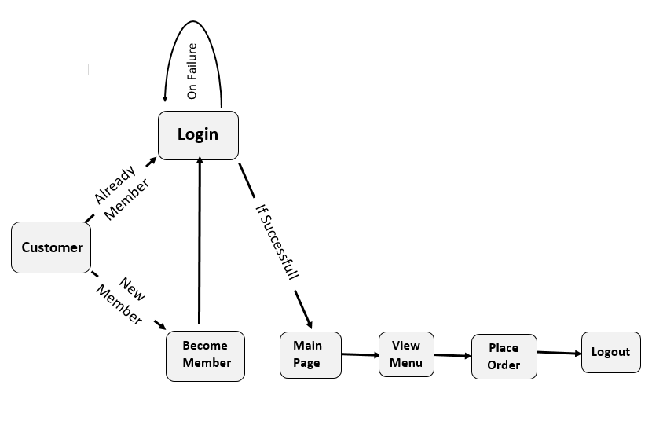

**PROJECT PROFILE**

Project Name : 🡪 **Fast Food Point**

Developed At : 🡪 Glorious College of Computer Science,

` At: Rajkot

Developed By : 🡪 **Pratvi Jikadra**

Main Pages : 🡪 Home, About us, Menu, Cart, Contact us, Login, Admin

Operating System : 🡪 Windows 11

Web Server : 🡪GlassFish Server

Web Browser : 🡪Google Chrome

Hardware Require

For Internet Access : 🡪 8 GB RAM

🡪 1 TB HDD

🡪512 GB SSD

🡪 intel Core i5 processor

🡪 Windows 11 OS

🡪 VGA Monitor with 800 X 600 or Higher resolution

🡪 Internet Connection through Telephone Line or Mobile

Thanks To : 🡪 Prashil Maheta Sir.

**PROJECT DEFINITION**

The **Fast Food Point** system is designed to automate and streamline the ordering, billing, and inventory management processes of a fast-food restaurant. This digital solution enhances efficiency, and improves customer satisfaction by ensuring quick and accurate service.

#### ****Key Objectives of the Project:****

1. **Customer Order Management:**
   * Allows customers to place orders online or at the counter.
   * Provides a user-friendly interface for menu browsing and order customization.
2. **Menu and Inventory Management:**
   * Tracks stock levels of ingredients and notifies management about low stock.
   * Helps in reducing food waste through efficient inventory tracking.
3. **Billing and Payment Integration:**
   * Automates the calculation of bills, including taxes and discounts.
   * Supports multiple payment methods (cash, card, upi,etc).
4. **User Role Management:**
   * Defines different access levels for **admins, and customers**.
   * Ensures secure handling of customer data and transaction records.
5. **Order Tracking and Notifications:**
   * Displays real-time order status updates for both customers and staff.
   * Sends notifications regarding order preparation and completion.
6. **Security and Data Management:**
   * Protects sensitive customer and transaction data using encryption.
   * Implements authentication and authorization for secure system access.

This system will **enhance the speed and accuracy** of fast-food operations, ensuring a **seamless experience for customers and restaurant staff alike**.

# SYSTEM ANALYSIS

* **Information Gathering**

The initial phase of system analysis involved understanding the structure and workflow of a fast-food restaurant, including how orders are placed, processed, and fulfilled. The business logic for each module, such as **menu management, order processing, analysis**, was analyzed. To gather requirements, a detailed study was conducted through research on existing fast-food management systems and discussions with industry experts.

* **Feasibility Analysis:-**

Feasibility analysis is a crucial step in assessing whether the **Fast Food Point** system is practical, efficient, and beneficial for the business. The study evaluates the system’s impact on the restaurant’s operations, its ability to meet user needs, and the resources required for development.Since **time, and financial resources** are key factors in any project, a feasibility study helps determine whether the system is **viable and worth implementing**.

* **Economic Feasibility:-**

Economic feasibility focuses on the **cost-benefit analysis** of the system. The **Fast Food Point** system is designed to minimize manual workload, reduce order processing errors, and enhance efficiency, leading to increased revenue and reduced operational costs.

* **Operational Feasibility:-**

Operational feasibility assesses how well the proposed system fits within the organization and its day-to-day operations. The **Fast Food Point** system is designed to be **user-friendly, efficient, and adaptable**, ensuring smooth integration into a restaurant’s workflow. The system provides a **fast and seamless ordering experience**, ensuring higher satisfaction levels. the system is highly **operationally feasible** and will significantly enhance restaurant operations.

* **Technical Feasibility:-**

Technical feasibility assesses whether the **Fast Food Point** system can be successfully developed and implemented using available technology. This evaluation includes factors such as **performance, reliability, maintainability, and scalability** of the system.

.

|  |  |
| --- | --- |
| **Project Name** | Fast Food Point |
| **Language Used** | Java |
| **Database** | Microsoft Access |
| **User Interface Design** | HTML,JAVASCRIPT,CSS |
| **Web Browser** | Mozilla, Google Chrome, IE8, OPERA |
| **Web Server** | GlassFish Server |
| **Communication Tools** | Intranet/Internet |
| **Software** | NetBeans IDE |

* **Schedule Feasibility:-**

To determine the schedule feasibility of the **Fast Food Point** project, it's important to assess the time required for each phase of development and compare it with the available timeline.

1. **Requirement Gathering and Analysis** (3-days)
2. **System Design** (1- weeks)
3. **Database Setup and Backend Development** (2-weeks)
4. **Frontend Development** (3- weeks)
5. **Testing and Debugging** (2-3 weeks)
6. **Deployment and Documentation** (1 weeks)
7. **Final Review and Presentation** (4-days)

* **Cost-Benefit Analysis:-**

A cost-benefit analysis is necessary to determine economic feasibility. The primary objective of the cost-benefit analysis is to find out whether it is economically worthwhile to invest in the project. If the return on the investment is good, then the project is considered economically worthwhile.

**ABOUT JAVA**

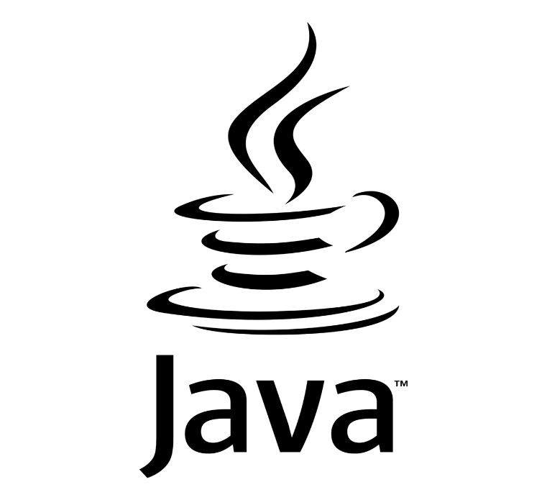

### ****Java Programming Language****

Java is a **high-level, object-oriented, platform-independent** programming language developed by **James Gosling** at **Sun Microsystems** (now owned by Oracle) and released in **1995**. It is widely used for developing web applications, mobile apps, enterprise software, and more.

### ****Key Features of Java:****

1. **Platform-Independent:**
   * Java follows the **"Write Once, Run Anywhere" (WORA)** principle.
2. **Object-Oriented:**
   * Java is based on **OOP concepts** like **encapsulation, inheritance, and polymorphism.**
3. **Simple and Secure:**
   * Java removes complex features like pointers (used in C++) to enhance security and simplicity.
4. **Automatic Memory Management:**
   * Java has **Garbage Collection**, which automatically handles memory allocation and deallocation.
5. **Multithreading:**
   * Java supports **multithreading,** allowing the execution of multiple tasks simultaneously.
6. **Robust and Reliable:**
   * Java provides features like **exception handling and strong memory management**, making applications more stable.
7. **Rich API and Libraries:**
   * Java provides a vast set of **predefined libraries** for networking, data structures, graphics, etc.

* **About HTML Hyper Text Markup Language**

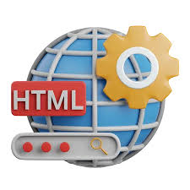

In 1980, physicist Tim Berners-Lee, who was an independent contractor at CERN, proposed and prototyped ENQUIRE, a system for CERN researchers to use and share documents. In 1989, Berners-Lee and CERN data systems engineer Robert Cailliau each submitted separate proposals for an Internet-based hypertext system providing similar functionality. The following year, they collaborated on a joint proposal, the Worldwide Web (W3) project, which was accepted by CERN.

* **About CSS Cascading Style Sheets**



CSS was developed by **Håkon Wium Lie** in **1994.** CSS is a stylesheet language used to control the layout and design of HTML web pages. It allows developers to apply colors,fonts, spacing, animations, andresponsive designs to enhance the appearance of a website. By mastering CSS, you can enhance the **user experience** and make web applications look modern and professional.

* **About JavaScript JavaScript**



**JavaScript (JS)** is a **high-level, dynamic, and interpreted** programming language used to create **interactive and dynamic** web pages. It was developed by **Brendan Eich** in **1995** while working at **Netscape.**JavaScript is one of the core technologies of web development, alongside **HTML and CSS.**

**About JSP**



##### 

##### JavaServer Pages

##### **JSP (JavaServer Pages**)**** is a **server-side technology** used to create **dynamic web applications** in Java. It was developed by **Sun Microsystems (now Oracle)** and released in **1999** as an extension of **Servlets** to simplify web development.

### ****Key Features of JSP:****

1. **Dynamic Content Generation** :

* Allows embedding Java code in HTML.

1. **Simplifies Servlets :**

* Reduces complexity by handling UI inside JSP files.

1. **Platform-Independent :**

* Runs on any server with a Java-enabled environment (e.g., Tomcat, GlassFish).

1. **Built-in Tags & Expressions** :

* Uses JSP tags like <%= %>, <% %>, and **JSP directives** to embed Java code.

1. **Faster Development** :

* Separates business logic (Java) from presentation (HTML).

1. **Supports MVC Architecture :**

* Often used with **Servlets and Beans** to follow **Model-View-Controller (MVC)** design.

##### About Servlet

##### 

A **Servlet** is a Java program that runs on a web server and handles client requests, usually over **HTTP.** It is a fundamental component of **Java EE (Jakarta EE)** used for building **dynamic web applications**.

### ****How Servlets Work****

1. **Client Sends a Request** → A user accesses a web page or sends data through a form.
2. **Servlet Processes the Request** → The server forwards the request to the servlet.
3. **Servlet Generates a Response** → The servlet processes data, interacts with the database if needed, and generates an HTML response.
4. **Client Receives the Response** → The response is sent back to the user’s browser.

### ****Key Features of Servlets****

✔ **Platform-Independent** – Runs on any Java-supported OS.  
✔ **Efficient & Scalable** – Unlike CGI scripts, servlets handle multiple requests using threads instead of creating new processes.  
✔ **Integration with Java EE** – Works with **JSP**, **JDBC**, and other Java EE technologies.  
✔ **Session Management** – Supports **cookies**, **URL rewriting**, and **HttpSession** for maintaining user sessions.

##### About GlassFish Server

##### 

##### GlassFish Server

### ****What is GlassFish Server?****

**GlassFish** is an open-source application server developed by Sun Microsystems (now owned by Oracle). It is used to deploy and run **Java EE (Jakarta EE)** applications, including Servlets, JSP, EJB, and RESTful web services.

### ****Key Features of GlassFish Server****

✅ **Supports Java EE (Jakarta EE)** – Fully compliant with enterprise Java standards.  
✅ **Fast & Lightweight** – Optimized for quick deployment and high performance.  
✅ **Modular Architecture** – Uses OSGi for flexibility and scalability.  
✅ **Built-in Admin Console** – Provides a web-based UI for managing applications.  
✅ **Supports Clustering** – Allows load balancing and failover support.  
✅ **Security & Authentication** – Integrates with Java Authentication and Authorization Service (JAAS).

##### 

##### PROJECT DIAGRAM

##### User Side

##### Admin Side

**DATA DICTIONARY**

* **Admin Table**

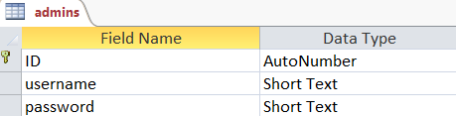

* **Customer Registration Table**

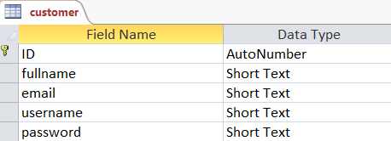

* **Contact Us Table**

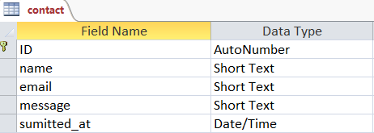

* **Food_Items Table**

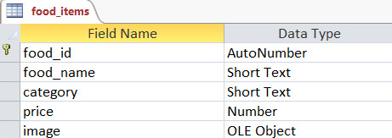

* **Order Table**

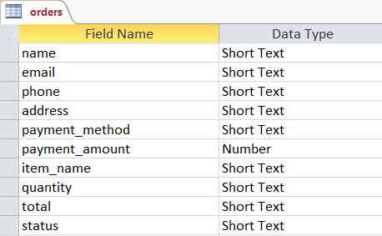

**PHYSICAL LAYOUT**

* **User Side**
* Home Page :

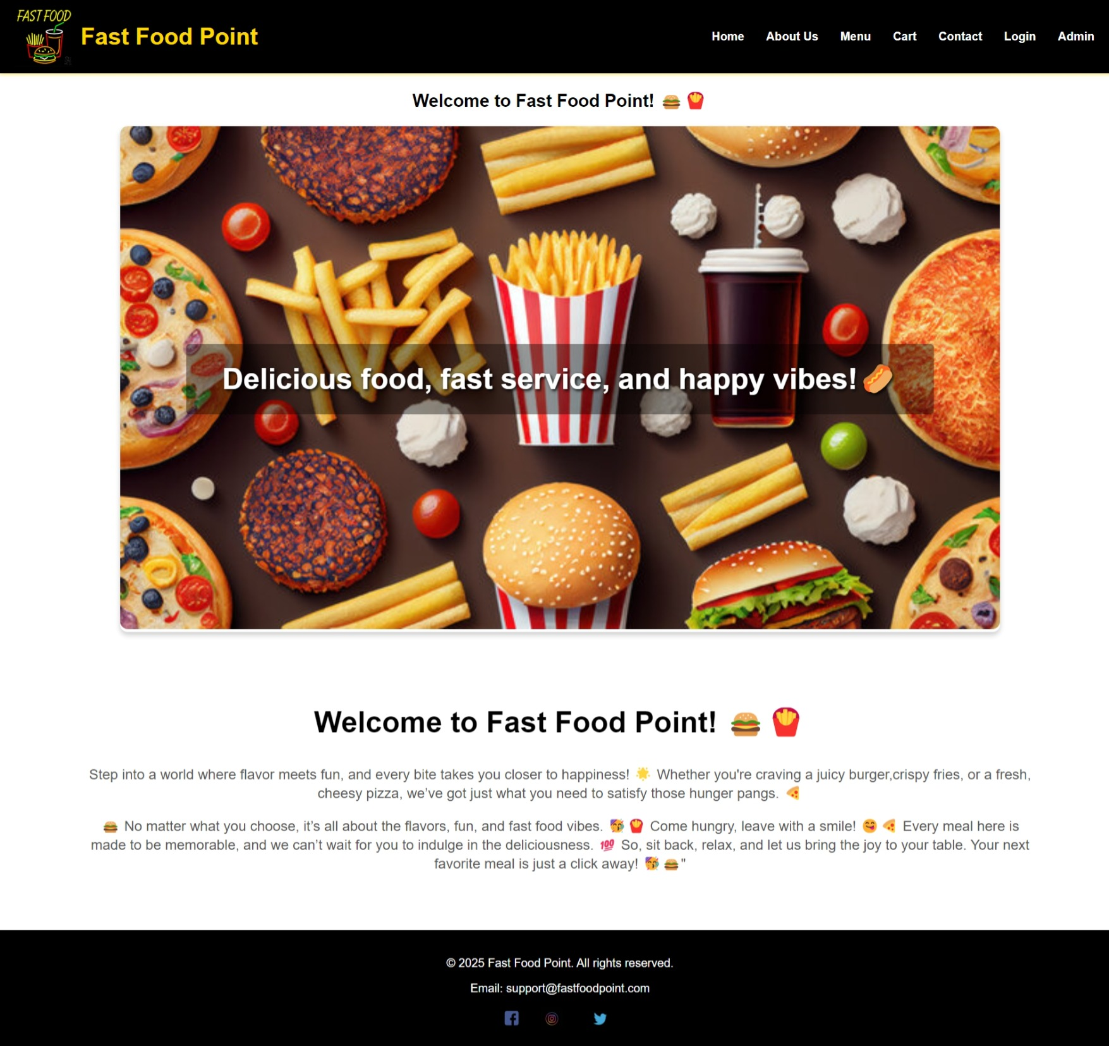

* 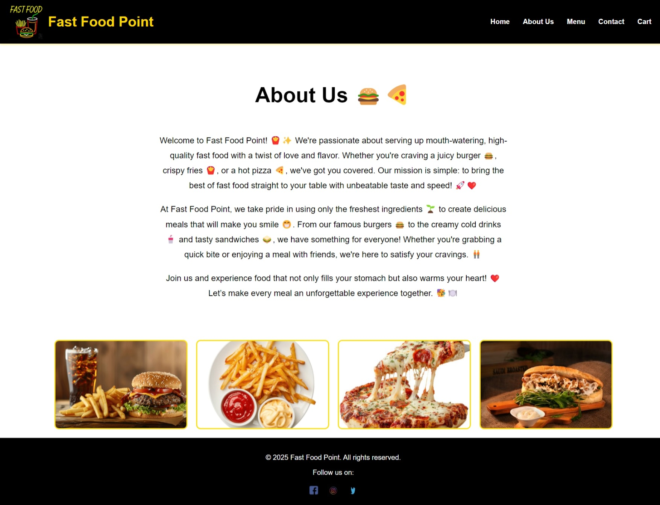About Us Page:
* Your Cart Page :

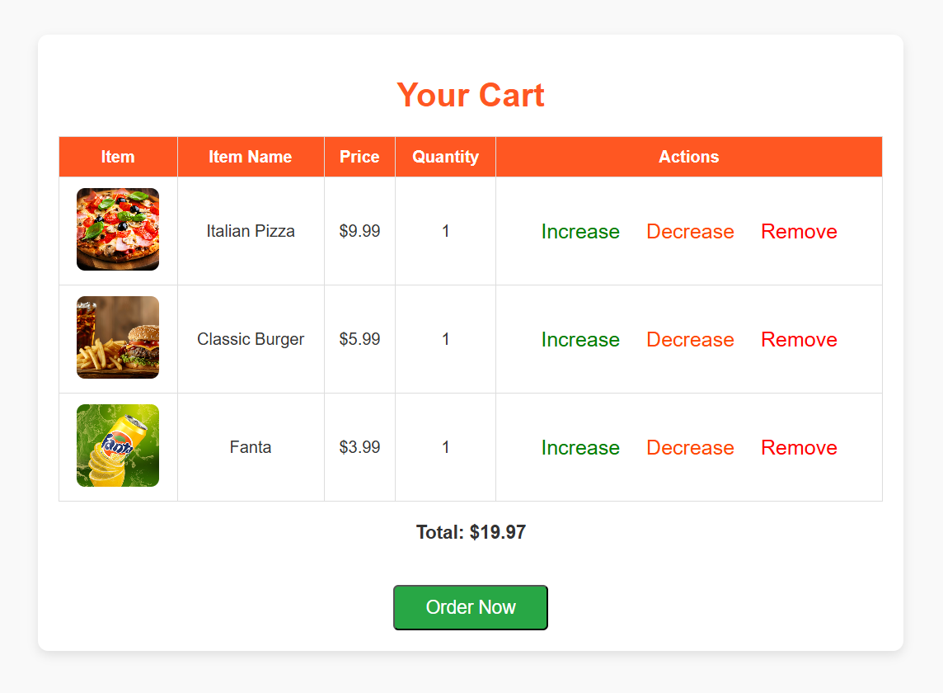

* Menu Page :

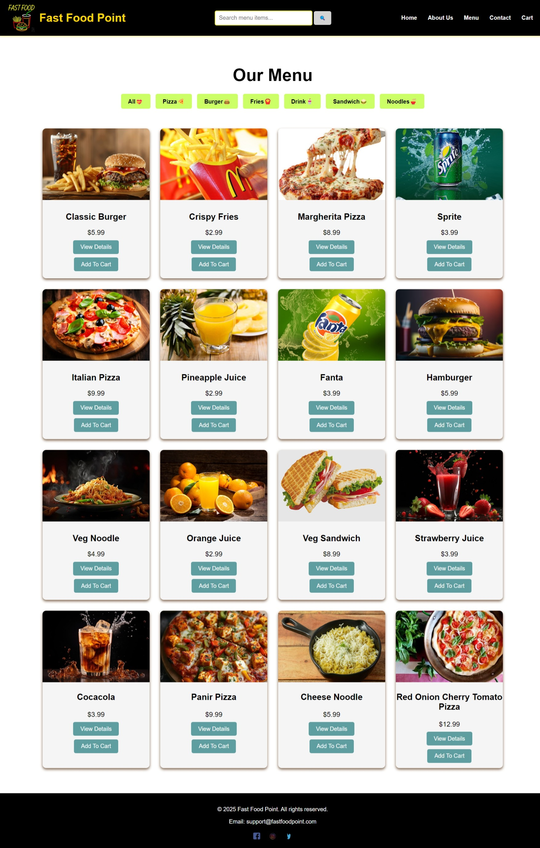

* + 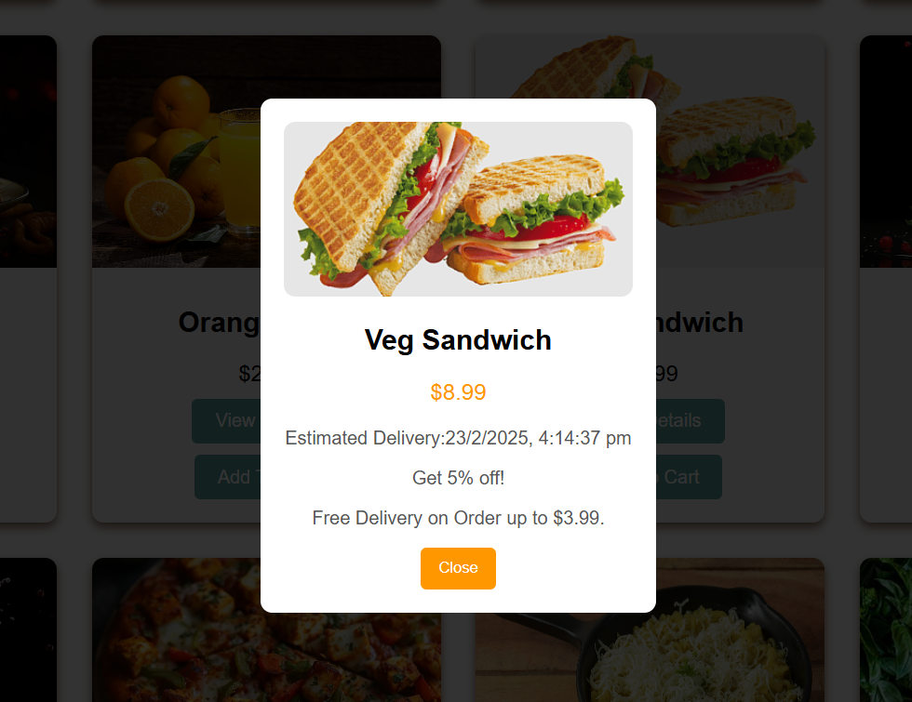View Details
* Contact Us Page :

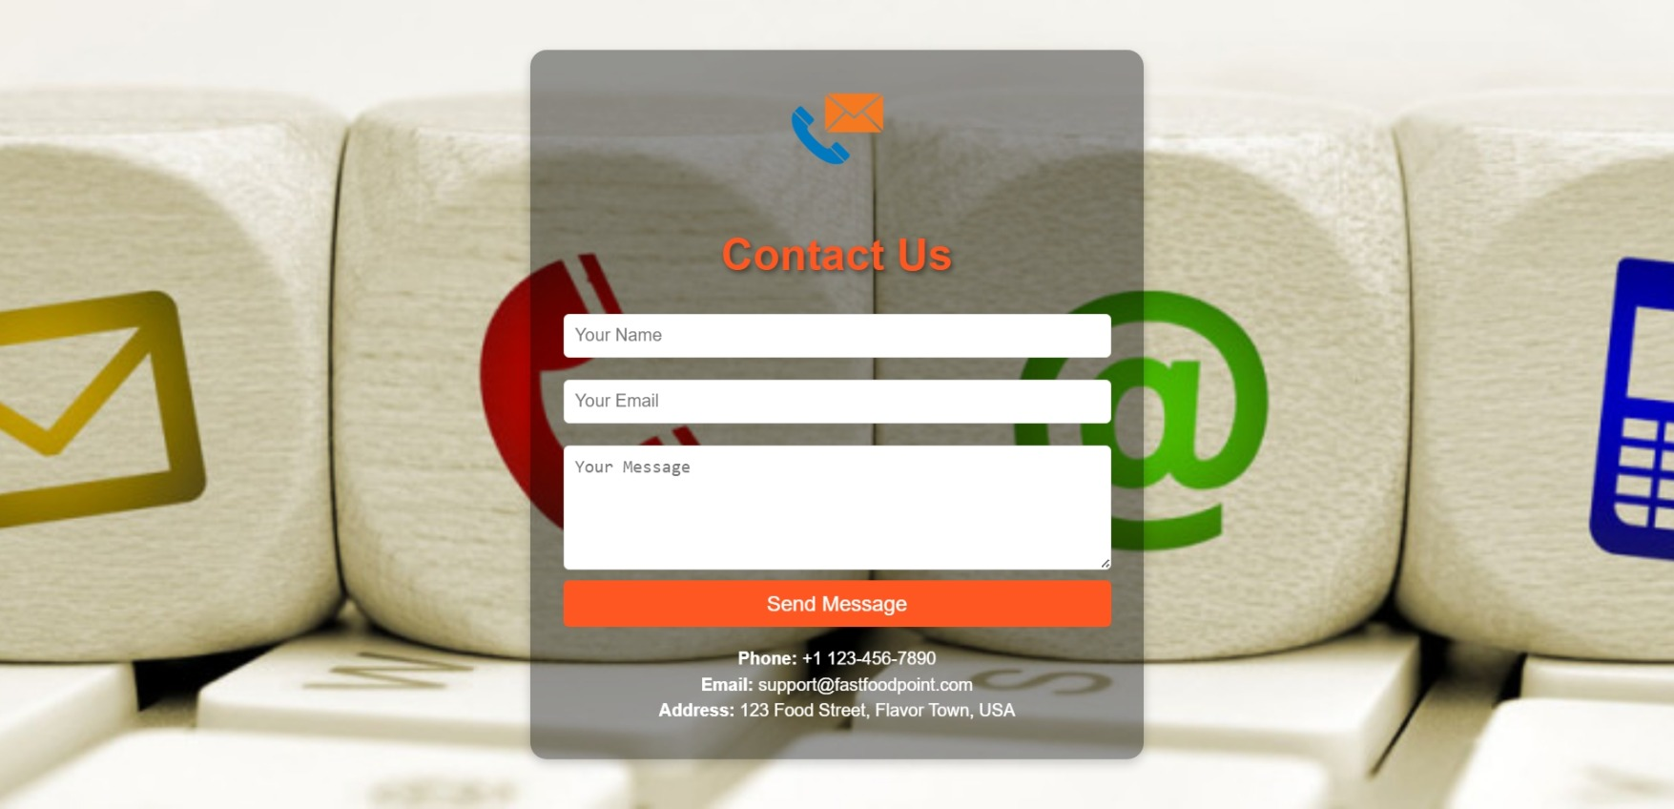

* Registration Page :

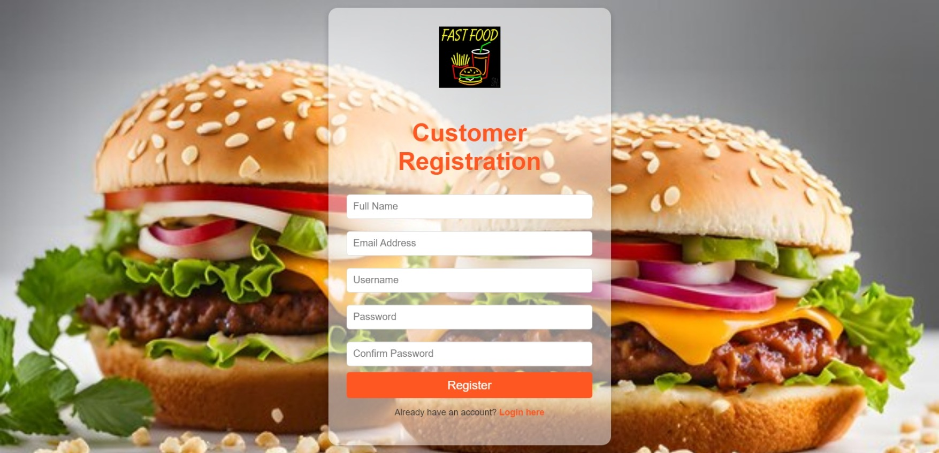

* 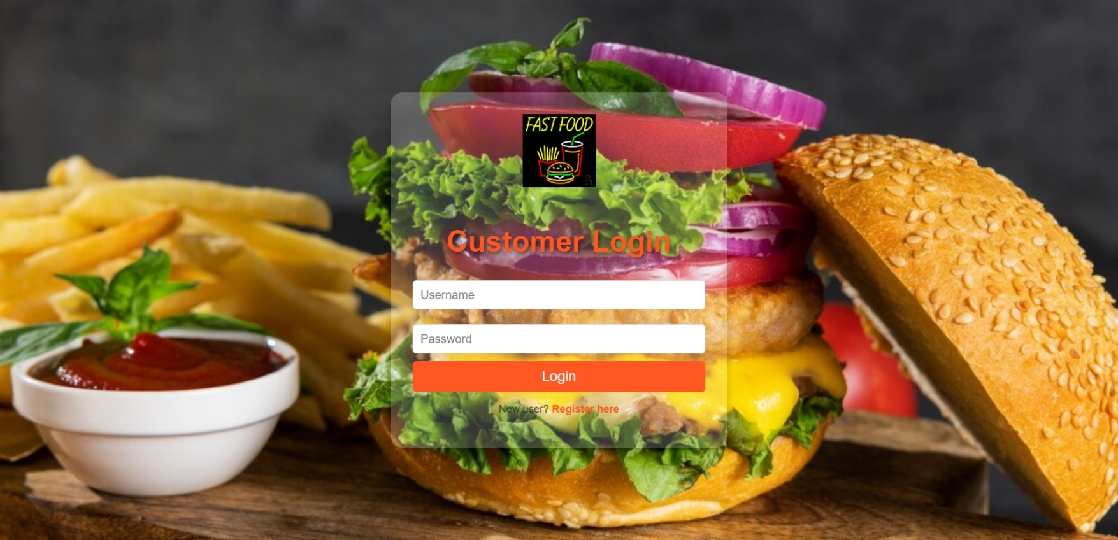Login Page :
* 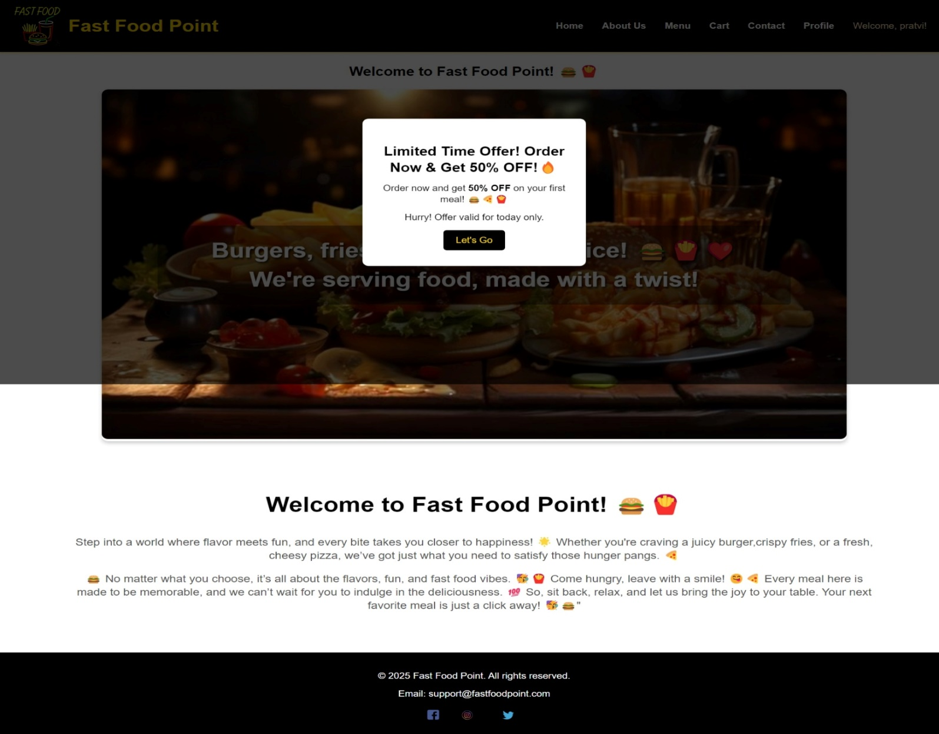Offer For User After Login :
* **Profile Page :** 
  + 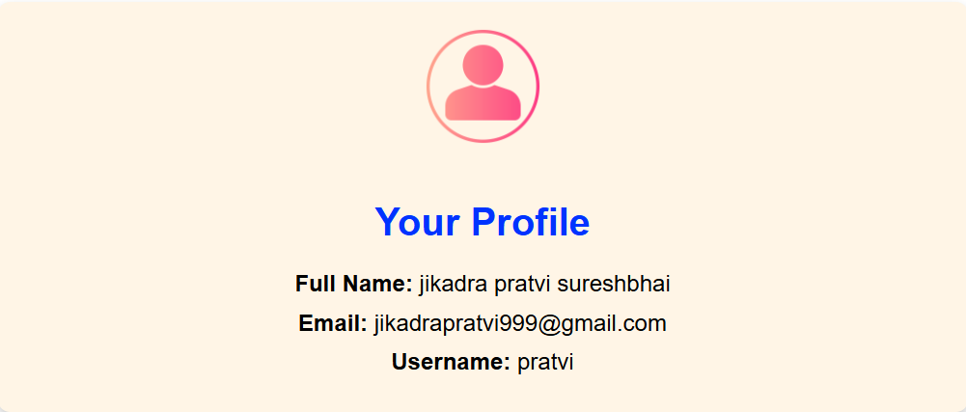 Show Profile :
  + 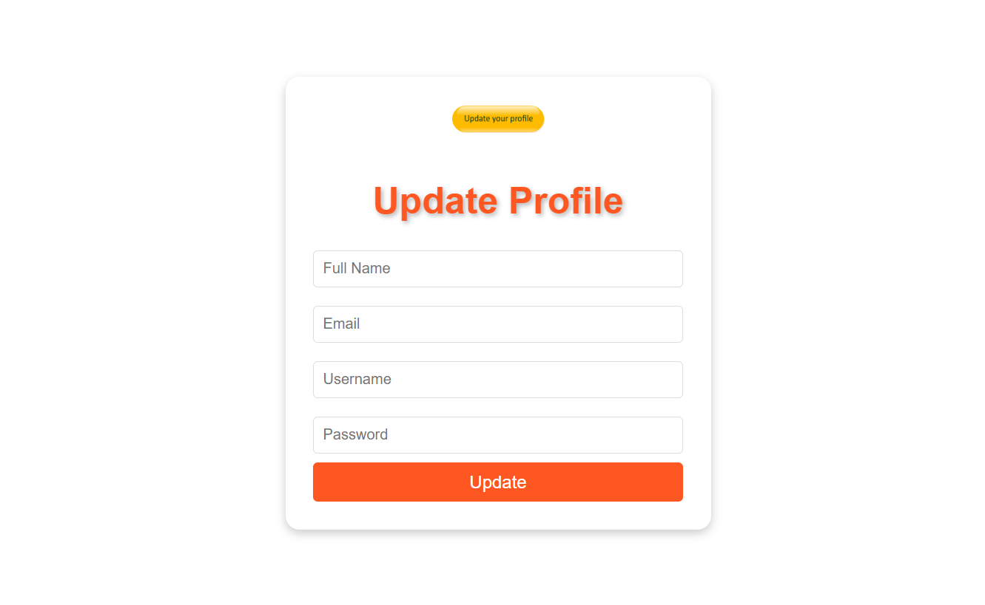Update Profile :
* Place Order Page :

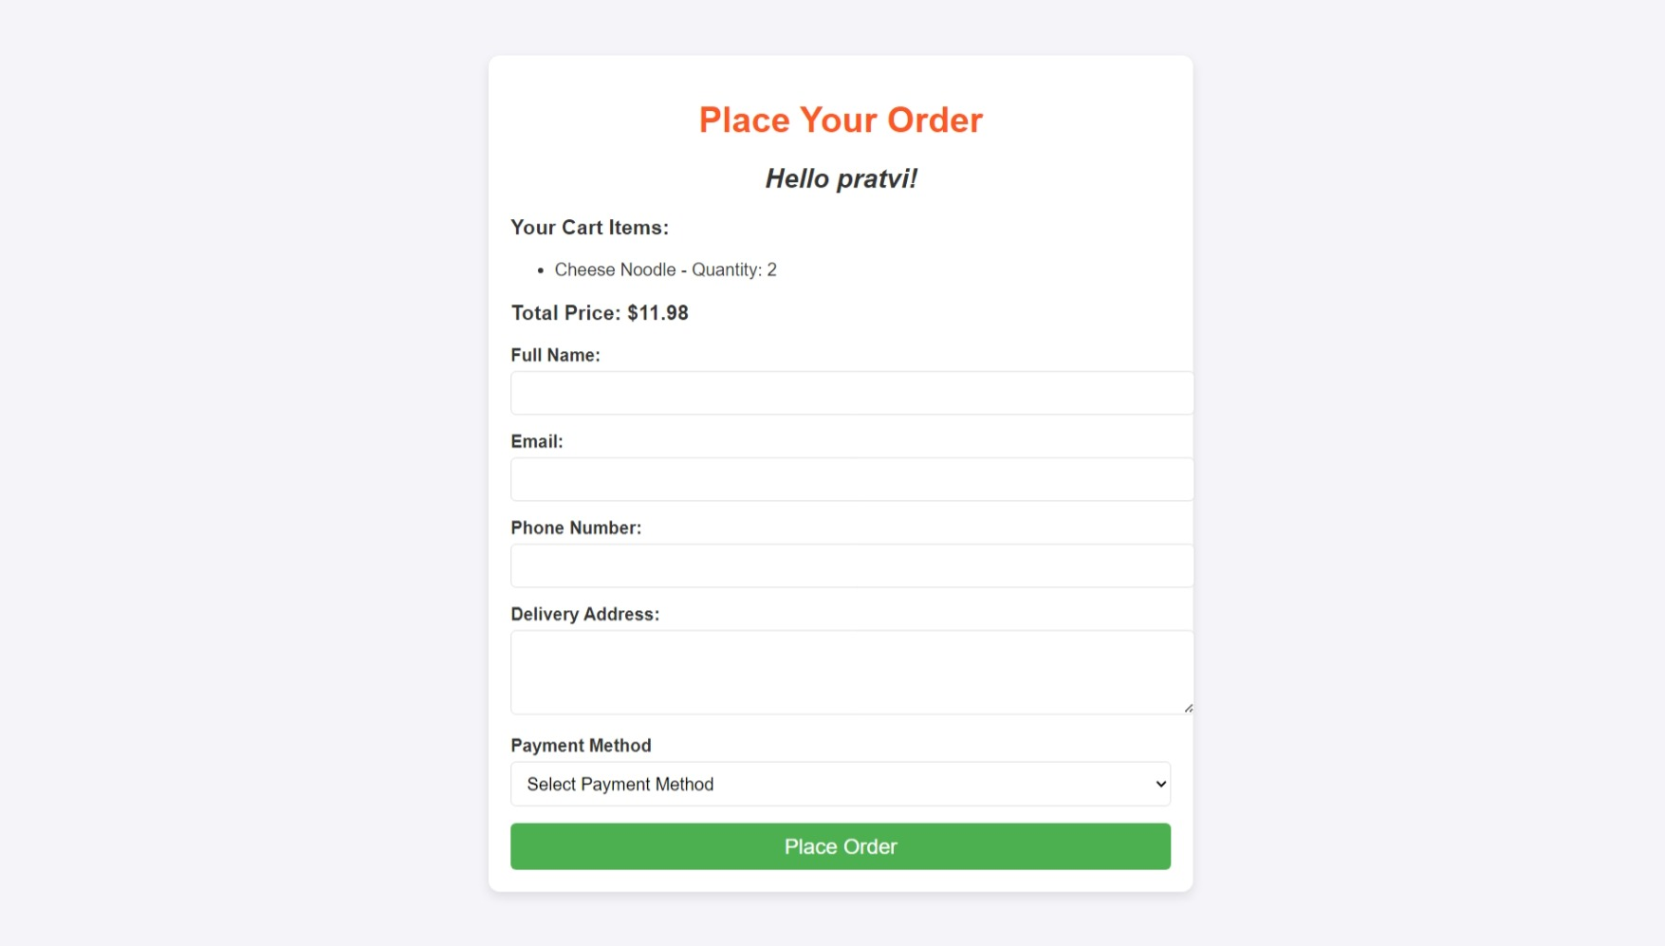

* + 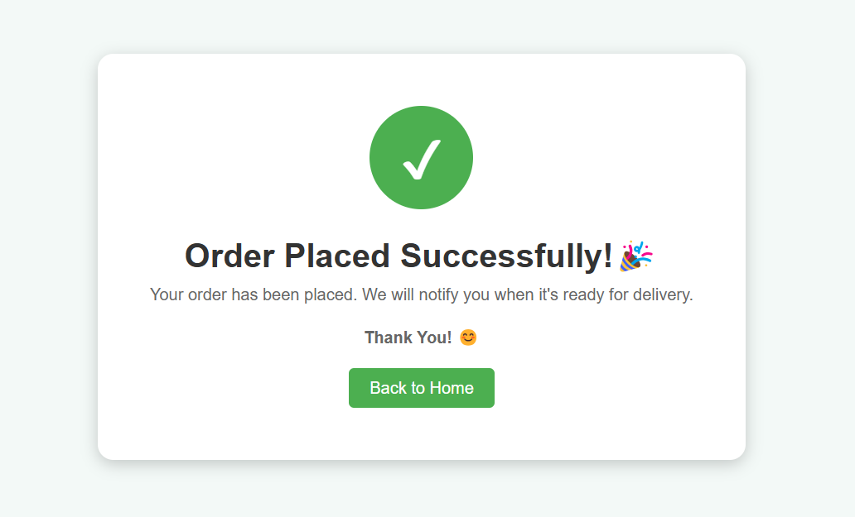Order Successful Page
* 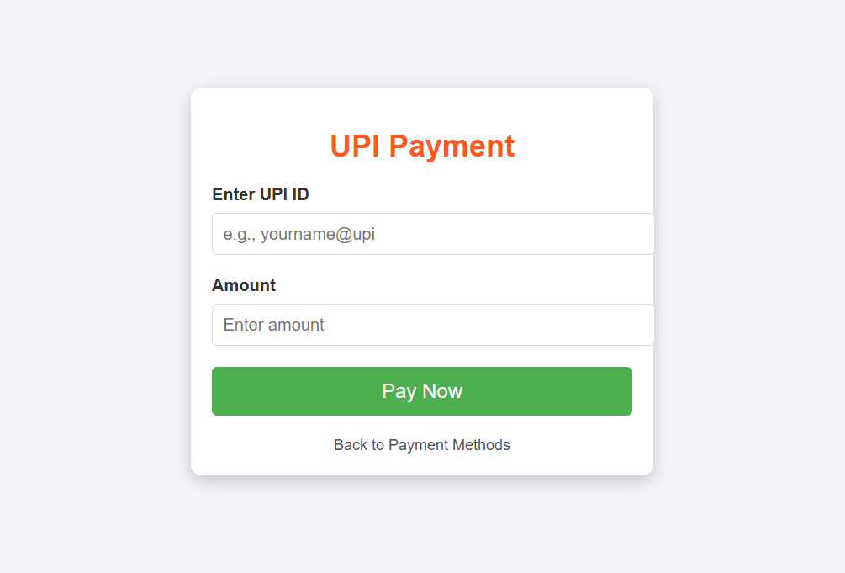UPI Payment Method :
  + 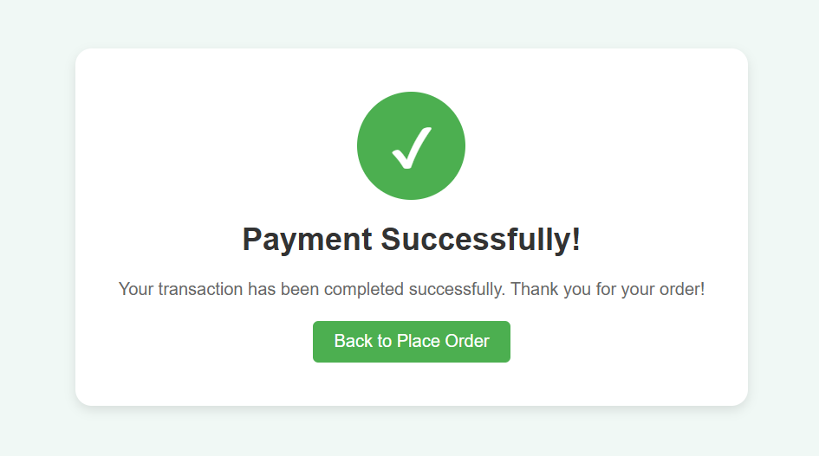Payment Successful Page
* **Admin Side**
* Login Page :
* 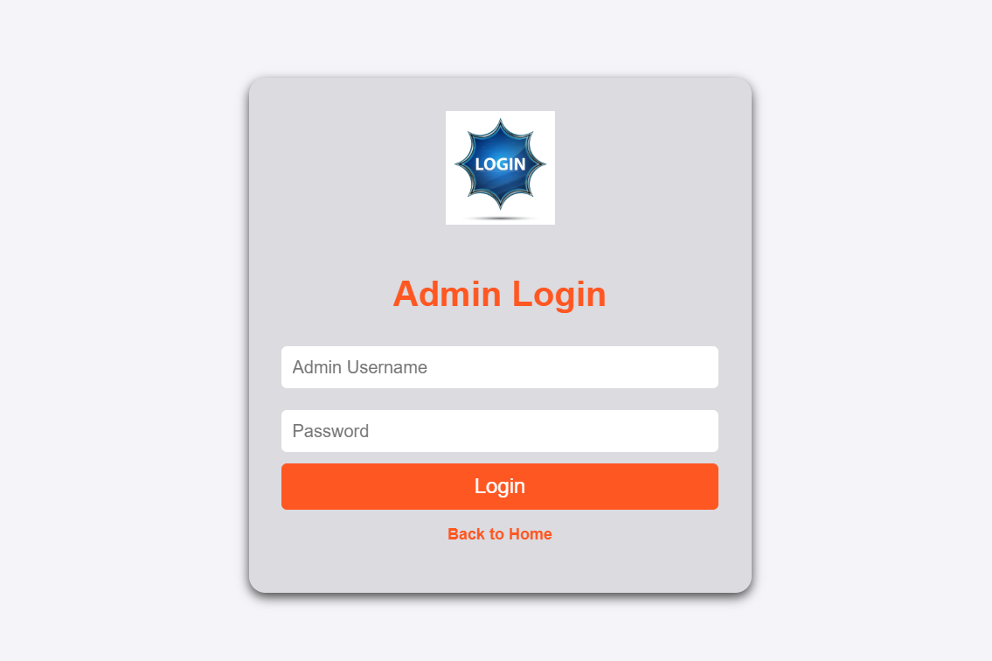
* Admin Dashboard :

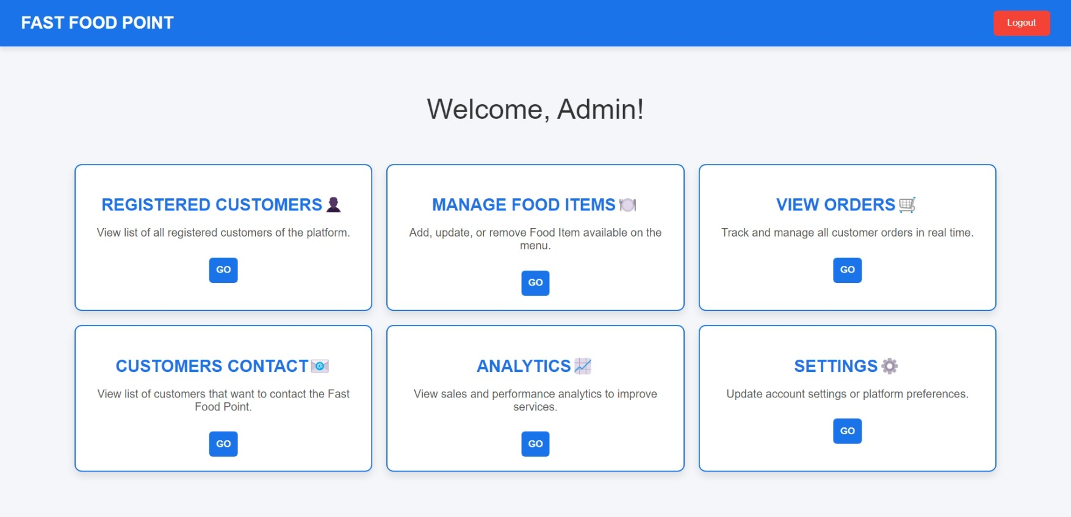

* 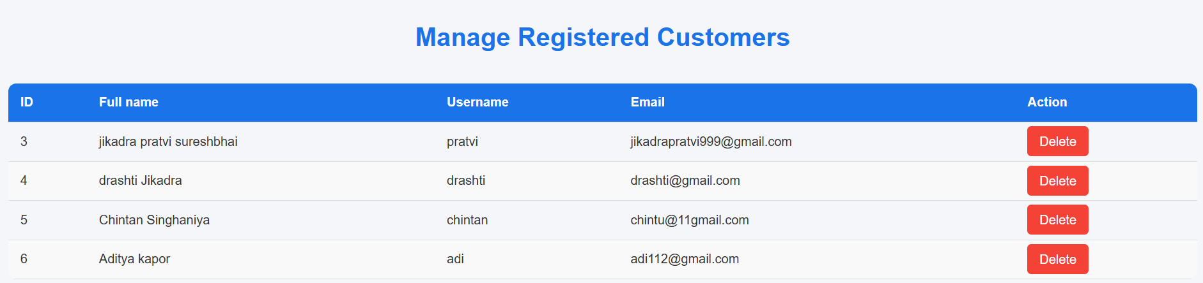Registered Customers Page :
* **Manage Food Item Page :**
  + 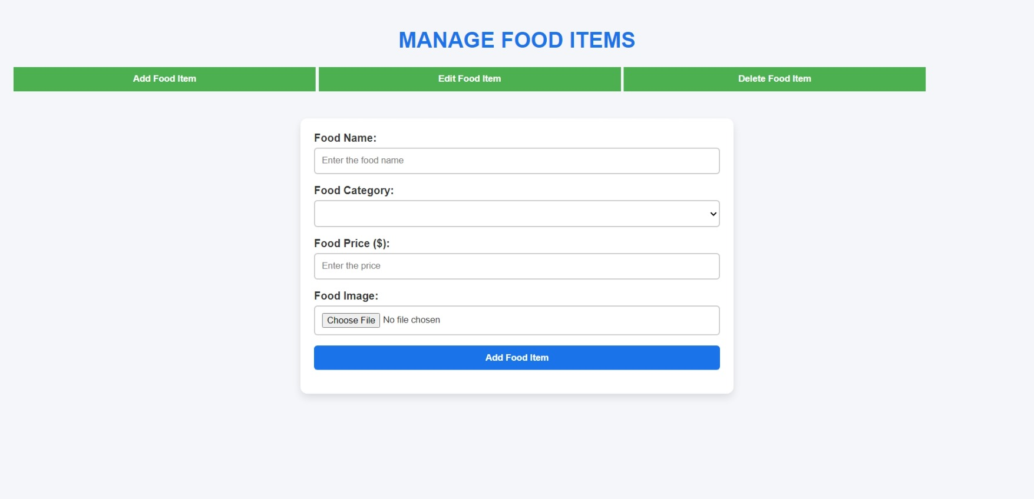Add Food Item :
  + 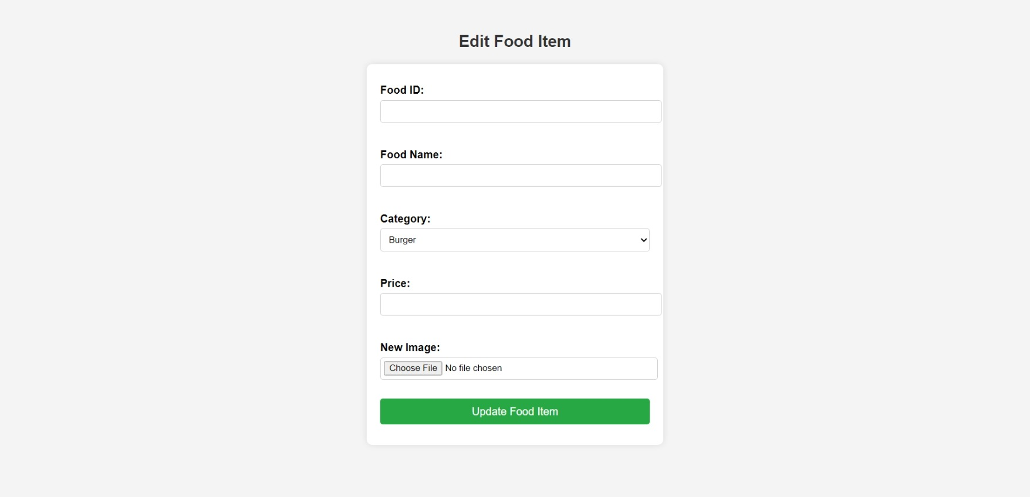Edit Food Item :
  + 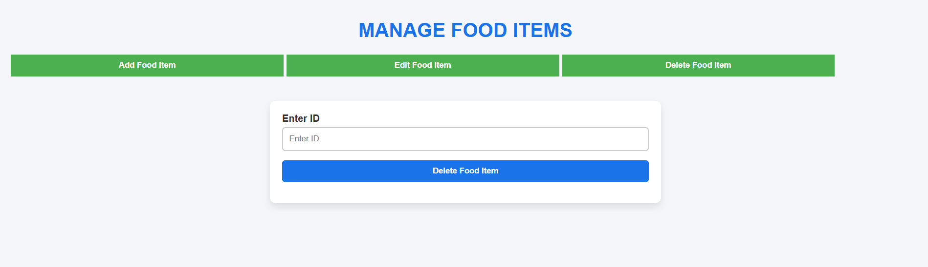Delete Food Item :
* 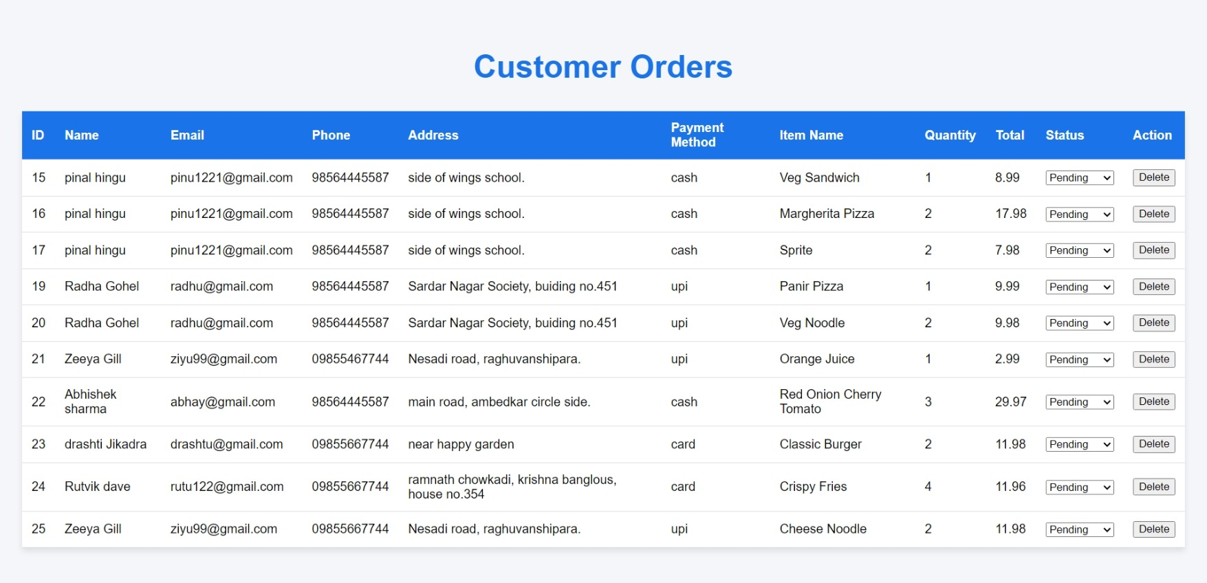View Orders Page :
* 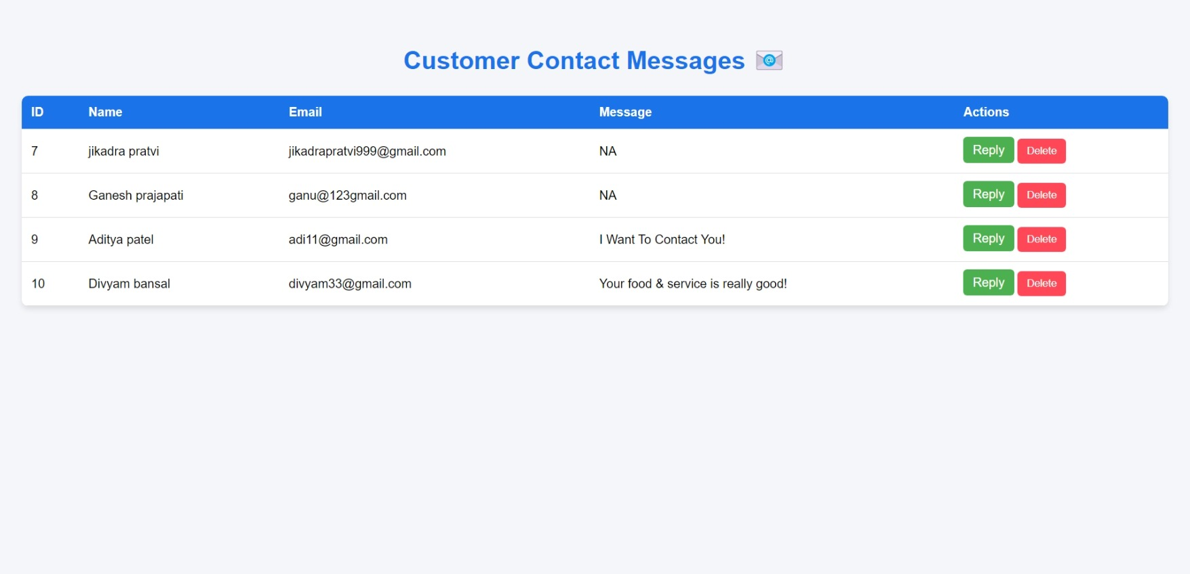Customer Contacts Page :
* **Analytics Page :**
  + 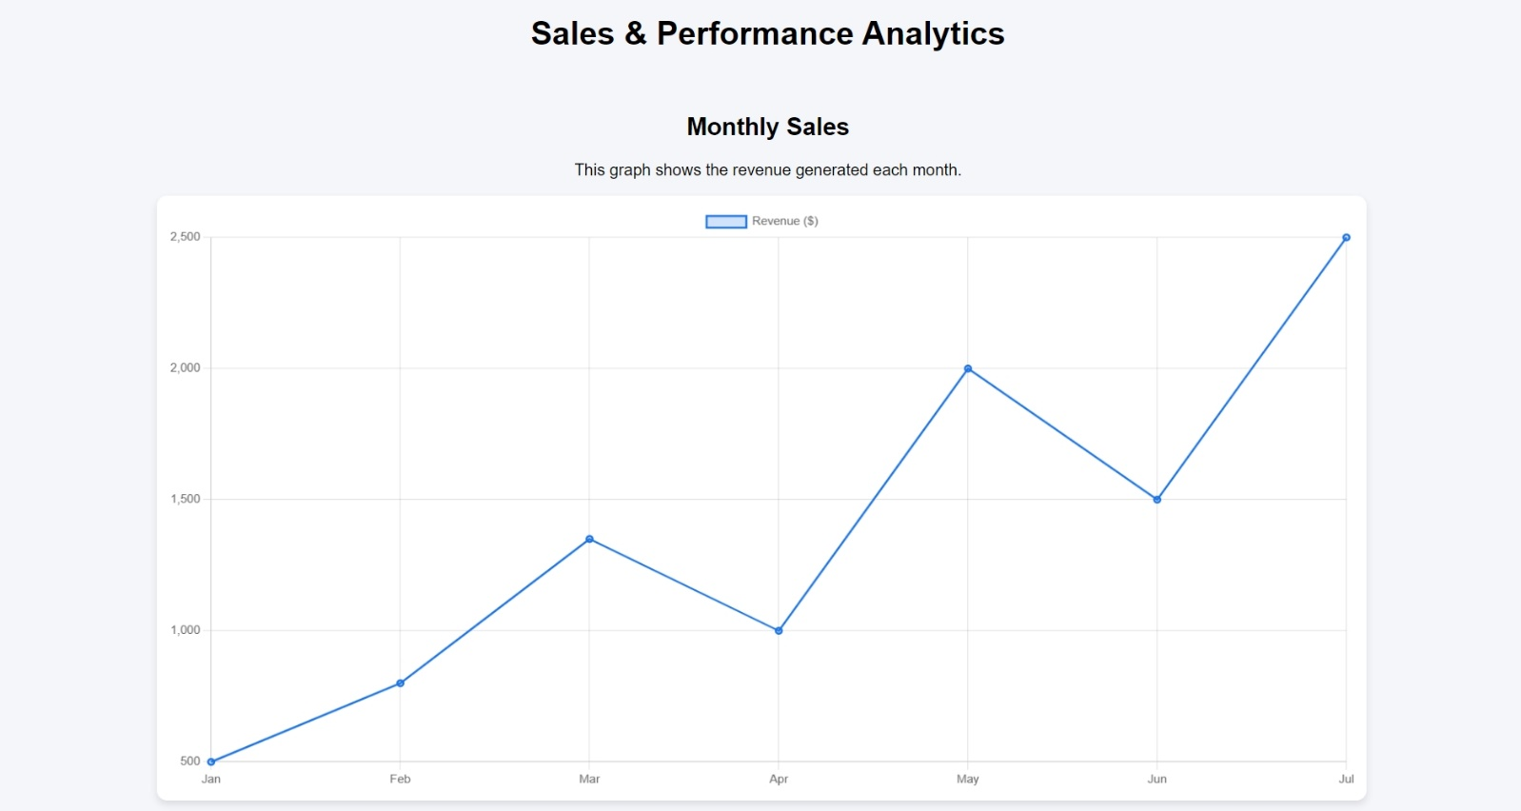Monthly Sales :
  + Top Selling Items :

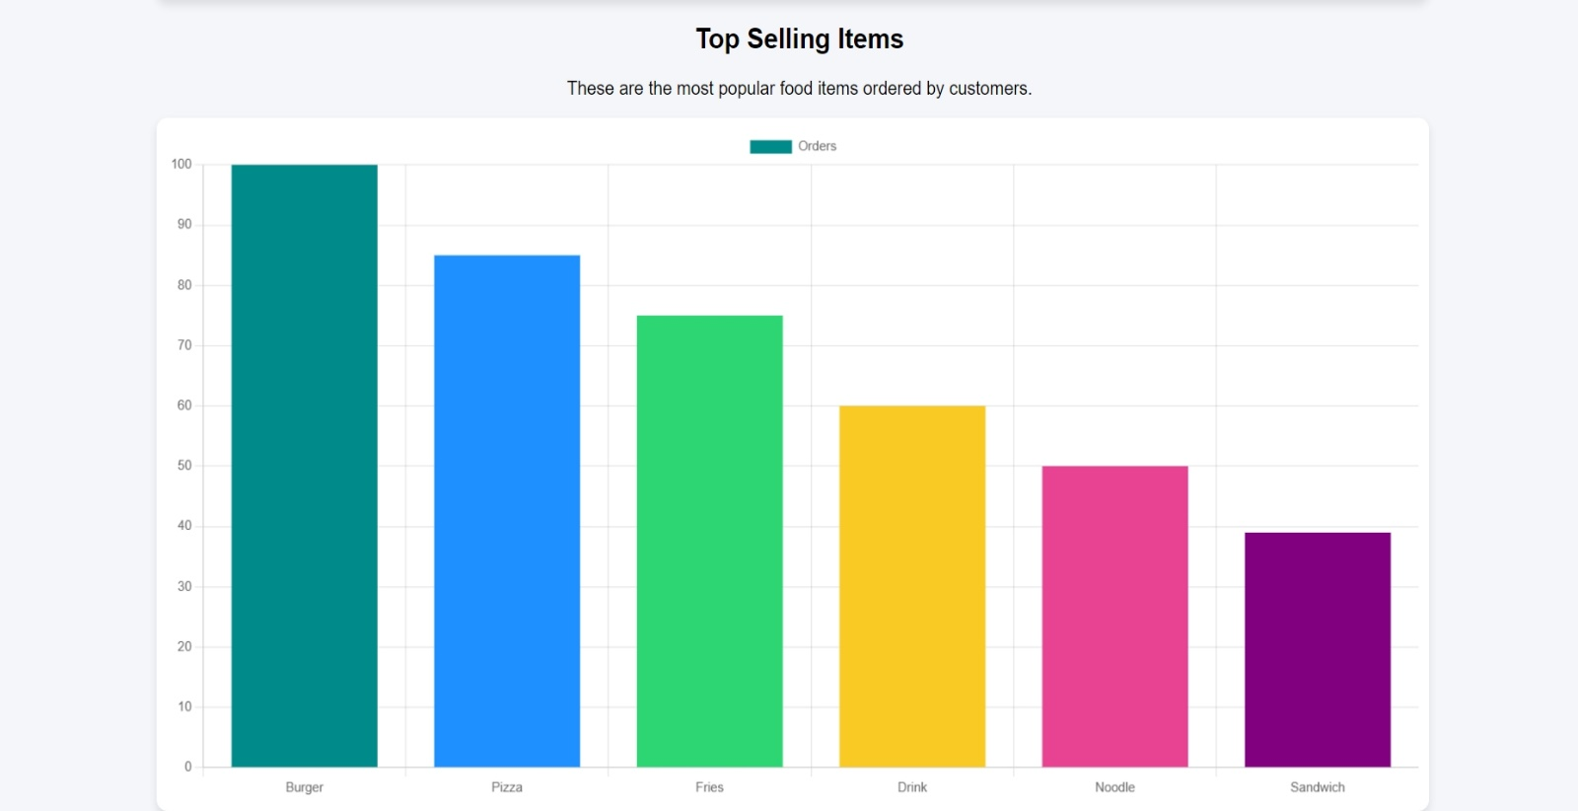

* + Customer Engagement :
* Admin Settings Page :

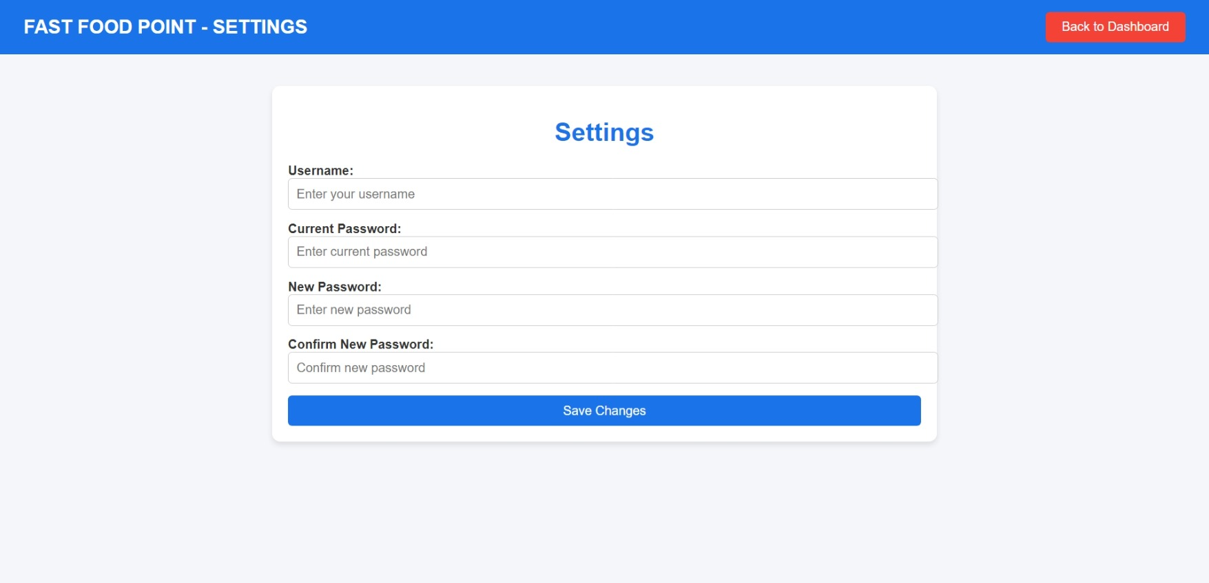

**Contact Us Info**

Name : - **Pratvi Jikadra**

Name of project : - Fast Food Point

Purpose : - In this project, users can explore our Fast Food

Point to view the menu, place orders, and get

details about our food offerings. They can also

send their orders and inquiries through the

website.

Abstract : - This web site describes the Many Different

Pictures. This site has the Collection of the

Fast Food Items.

Technology : - Java, Microsoft access database, glassfish server

**Project Schedule**

Project scheduling consists of identifying the tasks needed to complete the project, determine the dependency among different task, plan the starting and ending dates for various tasks and determine the chain of tasks that determine the duration of the project. In Project scheduling I decided the order in which to do the tasks, which I have described in work break down structure.

|  |  |  |  |  |  |  |
| --- | --- | --- | --- | --- | --- | --- |
| Process | Date | | | | | |
| 03-12-25  to  10-12-25 | 11-12-25  to  20-12-25 | 21-12-25  to  01-01-25 | 02-01-25  to  17-01-25 | 18-01-25  to  24-02--25 | 25-02-25  to  02-03-25 |
| Deciding Definition |  |  |  |  |  |  |
| Analysis |  |  |  |  |  |  |
| Design |  |  |  |  |  |  |
| Coding & Testing |  |  |  |  |  |  |
| Documentation |  |  |  |  |  |  |
| Deployment |  |  |  |  |  |  |

**Bibliography**

During the development of this project, various resources were referred to for research, design, and implementation. The following sources provided valuable guidance and knowledge:

1. **Books & Study Materials:**
   * Web Development with HTML, CSS, and JavaScript – Jon Duckett
   * Java: The Complete Reference – Herbert Schildt
   * Database Management Systems – Raghu Ramakrishnan
2. **Online Resources:**
   * W3Schools ([www.w3schools.com](https://www.w3schools.com)) – For HTML, CSS, and JavaScript references
   * GeeksforGeeks ([www.geeksforgeeks.org](https://www.geeksforgeeks.org)) – For Java, JSP, and database concepts
   * Oracle Documentation ([docs.oracle.com](https://docs.oracle.com)) – For Java EE and GlassFish Server
3. **Software & Tools Used:**
   * NetBeans IDE – For developing and running the application
   * GlassFish Server – For deploying the web application
   * Access Database – For storing user and order details
4. **Other References:**
   * Various online tutorials, research articles, and forums such as Stack Overflow for debugging and troubleshooting issues.

